English Vocabulary – The Five Senses
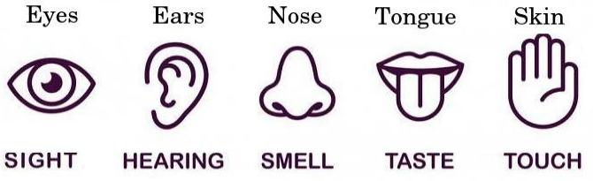

Sight Taste
Verbs: to see, to watch, to look Verb: to taste
Adjectives: visual, optical, visible, invisible Adjectives: tasty, tasteless
Nouns: sight, vision Noun: taste, palate
Inability to see: to be blind

Hearing Smell
Verbs: to hear, to listen to Verb: to smell, to stink
Adjectives: audio, audible, inaudible Adjectives: smelly, stinky, fragrant
Noun: hearing Nouns: smell, aroma, fragrance
Inability to hear: to be deaf

Touch
Verbs: to touch, to feel
Adjectives: tactile, tangible, intangible
Noun: touch

Conversation 1. Which senses do these activities use?
- eating pizza
- drinking coffee
- kissing
- cleaning the house
- playing a musical instrument
- using a computer
- playing football

Conversation 2. Can you think of an activity that uses all five senses?

Conversation 3. In your opinion, which sense would be the worst to lose? Why?

